**Name:Attay Rasool**

**Roll no:p180046**

**Section A**

**Lab No 04**

**Task 01**

**DNS SERVER CONFIGURATION:**

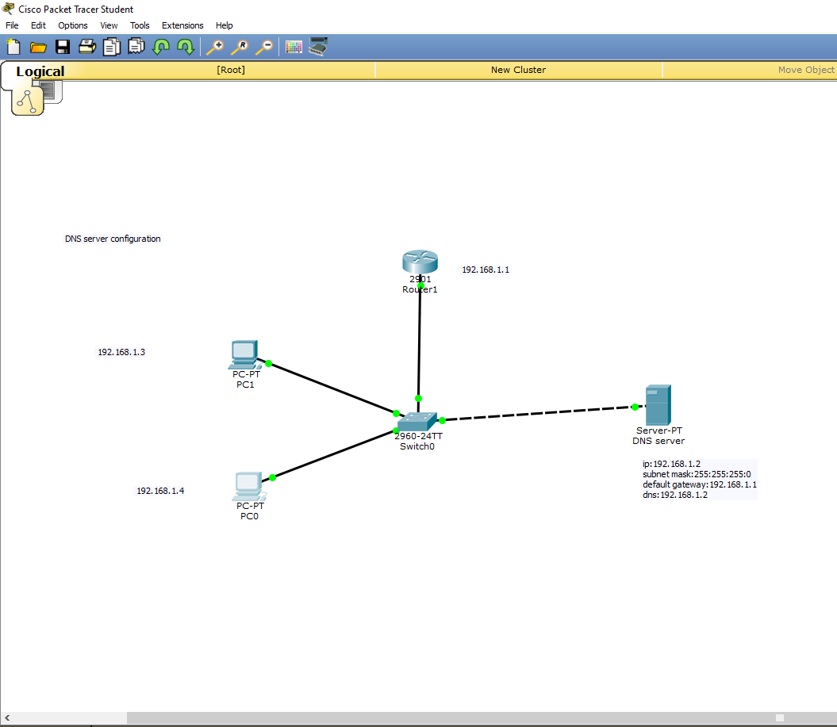

**Dns configuration:**

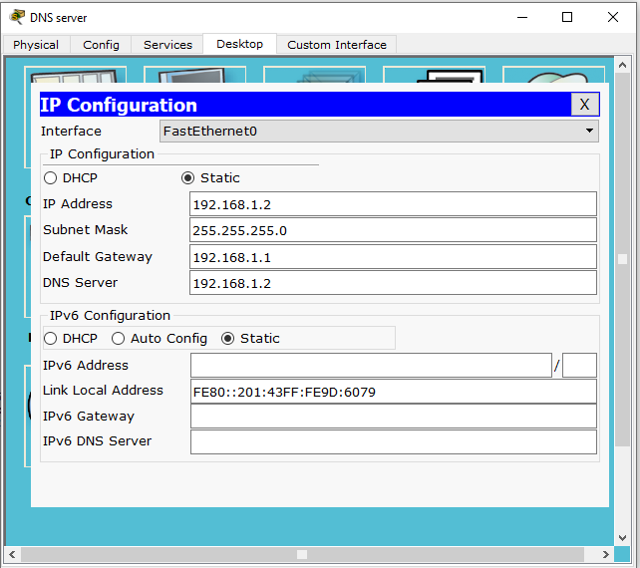

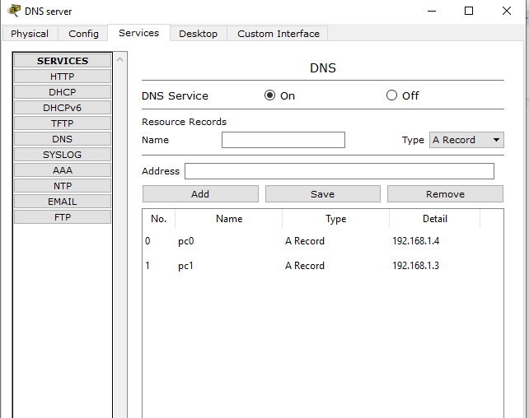

**Ping pc1 from pc0**

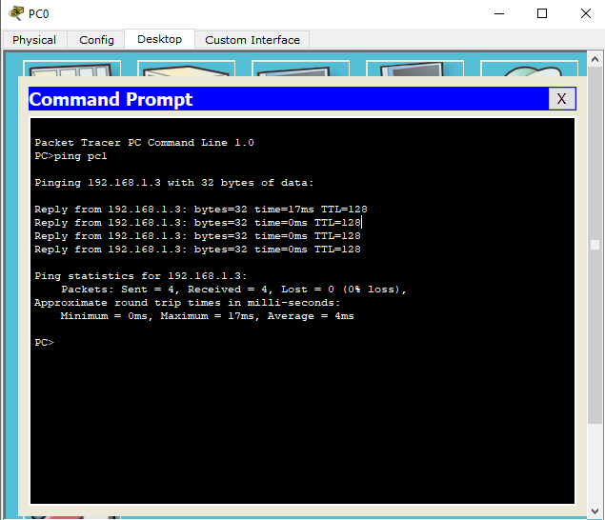

**Lab task 02**

**Configuration DHCP server on a Router**

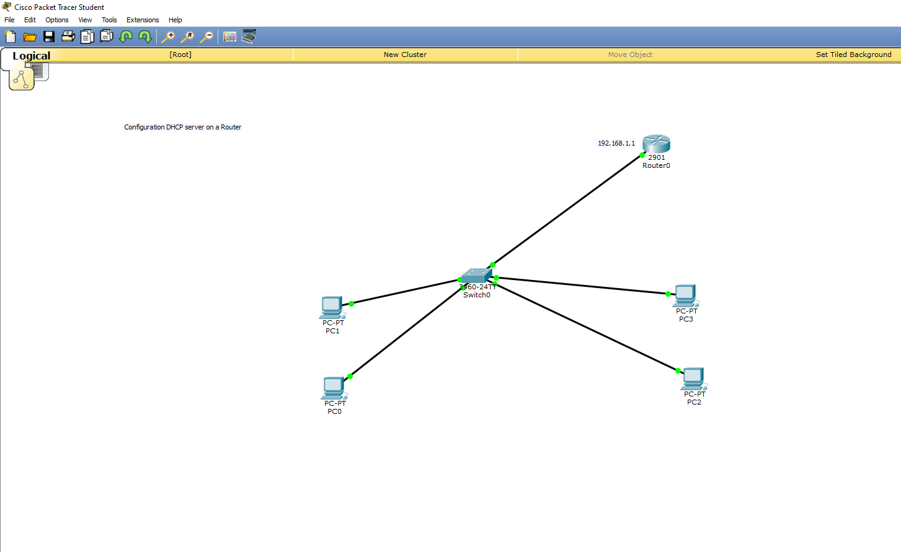

* On the router, configure interface GigabitEthernet0/0 to act as the default gateway for our LAN.

**CLI:**

Router>enable

Router#configure terminal

Enter configuration commands, one per line. End with CNTL/Z.

Router(config)#interface GigabitEthernet0/0

Router(config-if)#ip address 192.168.1.1 255.255.255.0

Router(config-if)#no shutdown

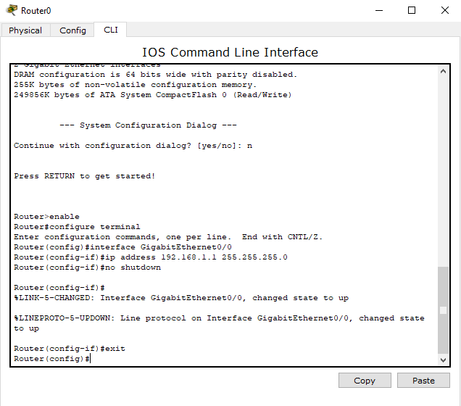

**DHCP pool:**

Router(config)#ip dhcp pool p1

Router(dhcp-config)#network 192.168.1.1 255.255.255.0

Router(dhcp-config)#network 192.168.1.0 255.255.255.0

Router(dhcp-config)#default-router 192.168.1.1

Router(dhcp-config)#dns-server 192.168.1.10

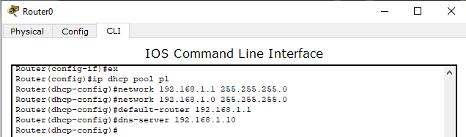

**Click PC1->Desktop->IP configuration. Then enable DHCP:**

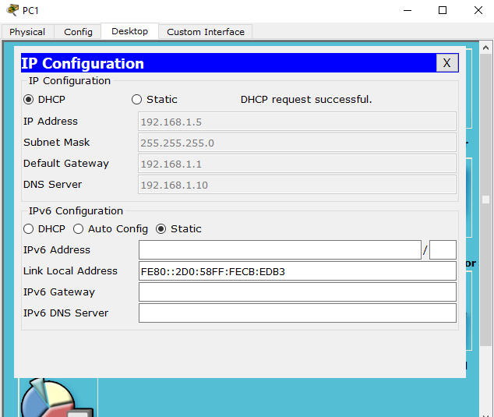

**Task 03:**

1. Configure static IP address on the server (192.168.1.2/24).

2. Now configure DHCP service on the generic server.

3. To do this, click on the server, then click on Services tab. You will pick DHCP on the menu. Then

proceed to define the DHCP network parameters as follows:

v Pool name: MY_LAN

v Default Gateway: 192.168.1.1

v DNS Server: 192.168.1.2

v Start IP Address: 192.168.1.0

v Subnet Mask: 255.255.255.0

v Maximum Number of users: 256

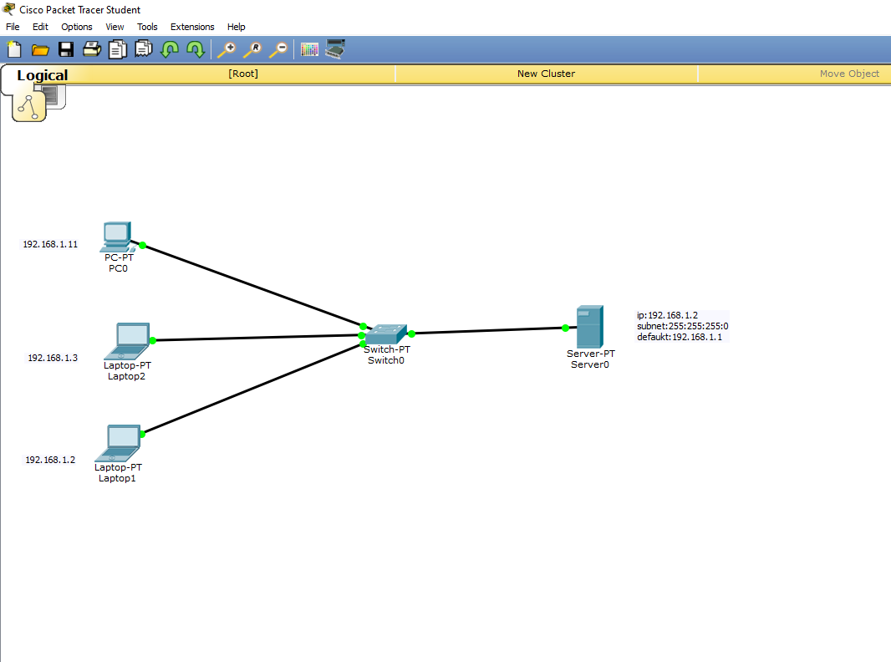

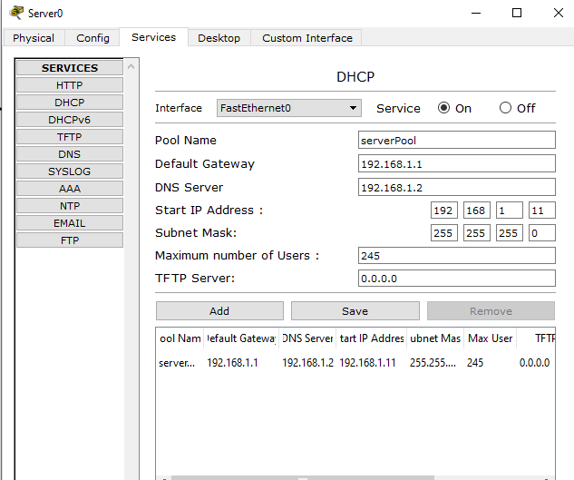

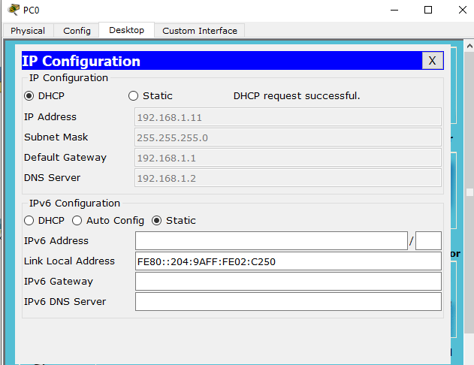

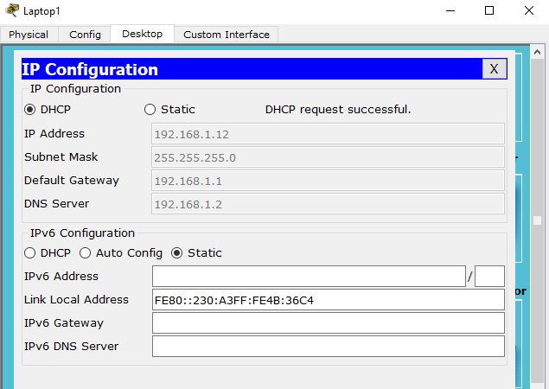

**Task 04:**